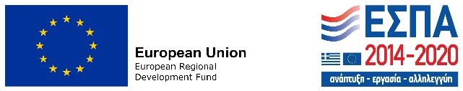

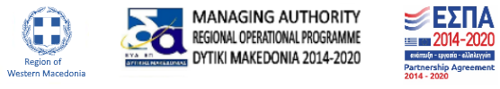
The enterprise …………………………… which is located in the Region of Western Macedonia, was co-financed by the European Regional Development Fund (ERDF) of the European Union (ΕΕ) for the implementation of its project under the Action "Liquidity support to very small and small enterprises affected by Covid-19 pandemic in Western Macedonia” under the framework of the Operational Program «Dytiki Macedonia» 2014-2020.
The Action supports micro and small enterprises in the Region of Western Macedonia with a non-repayable grant in order to ensure sufficient liquidity and to reduce the impact of the Covid-19 pandemic.
Investment’s total budget is…………………………………………………….. (100% public expenditure). The Action is co-financed by Greece and the European Union - European Regional Development Fund.
LIQUIDITY SUPPORT TO VERY SMALL AND SMALL ENTERPISES AFFECTED BY COVID-19 PANDEMIC IN WESTERN MAKEDONIA

